FACULTY EVALUATION
Programme Name: Social Entrepreneurship Program (SEP) – SCALE MASTERCLASS Module 2 (ONLINE)– Uganda (1st June 2026 - 5th June 2026)
Session: Reflections and Way Forward ||Wrap Up Session/ Questions and Answers, Next Steps
Faculty Name: Dr. Nancy Njiraini
No. of Respondents: 7
No. of Participants: 10
Evaluation Parameter | (%) Individual Score | (%) Programme Average
Punctuality (Commencement and Completion of Sessions) | 83 | 83
How well do you understand the core concepts presented? | 90 | 90
Rate your confidence in applying the new skills learnt | 87 | 83
Degree of Faculty preparedness for the sessions | 97 | 94
Content and methodology of the program | 97 | 93
Quality of class and group discussions | 93 | 90
The information presented in the course is relevant to my work (ministry) | 97 | 94
Average scores | 92 | 90

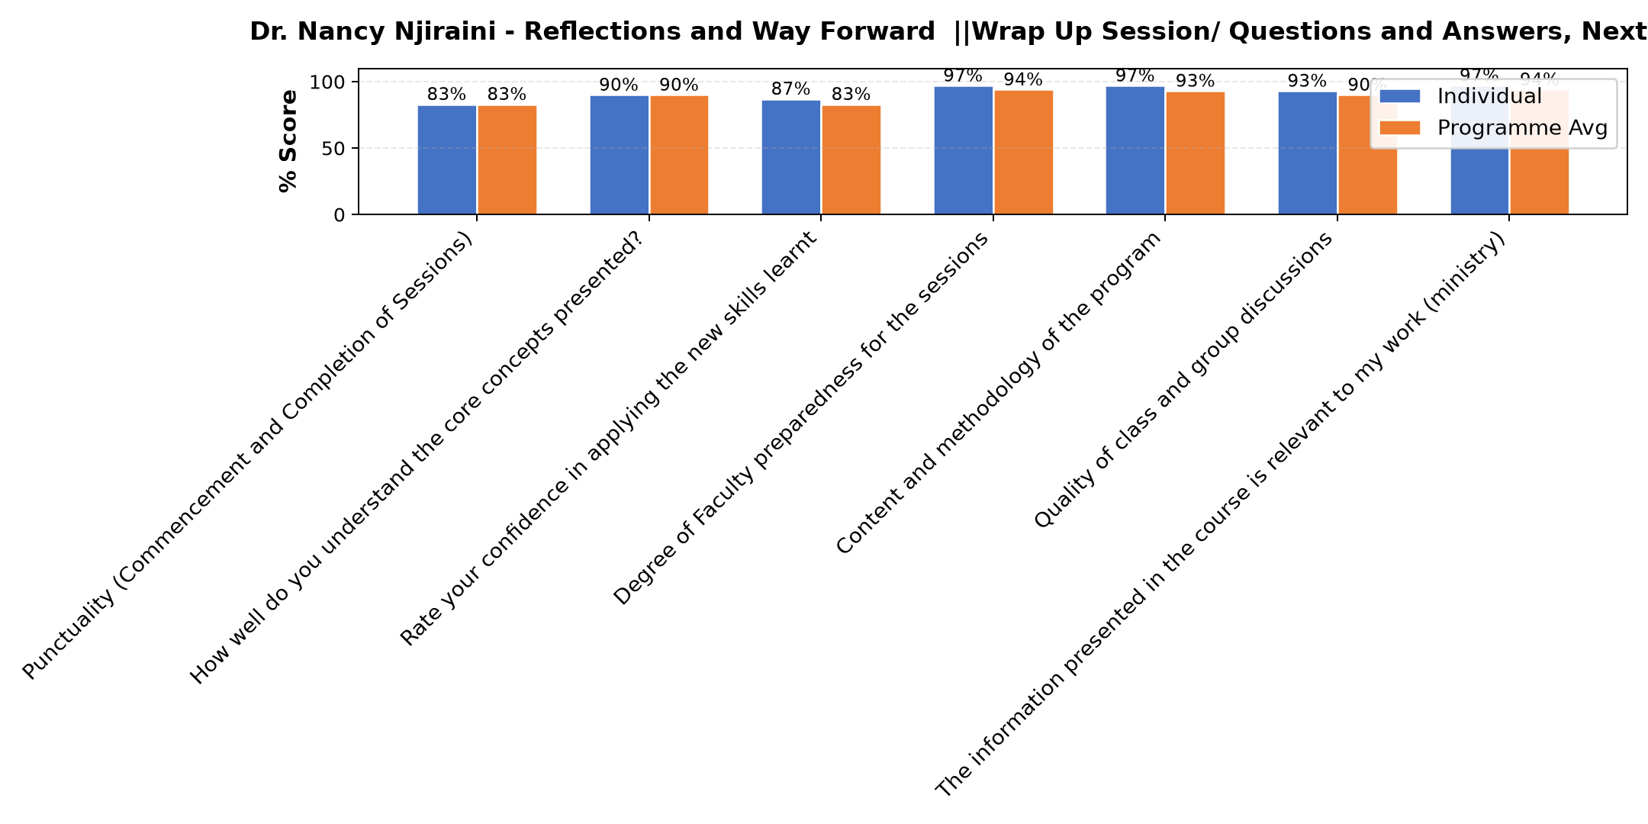

Comments & Feedback
- • Conflicting priorities – Day-to-day crises overshadow applying new knowledge.
Time Constraints — Running a nursery and primary school on a daily basis is demanding. Finding dedicated time to step back and work on the business rather than in it remains a significant challenge.
Limited Technical Expertise — Some of the funding application processes and impact measurement frameworks require technical skills that we may need additional support or training to fully implement.
Access to the Right Funders — Identifying and connecting with funders who specifically support early childhood education in our region can be difficult, especially without an established network.
- • Lack of data
SUBMITTED THROUGH:
SBS Evaluation Automation System

